I Press Release
Available for Immediate release
Intec’s innovative protective face shields keeps businesses productive
United Kingdom, 23 April 2020 – Known for its innovative auto feed cutting solutions, Intec Printing Solutions Limited, enables printers to stay productive by producing PPE Visors for the health and care sectors.
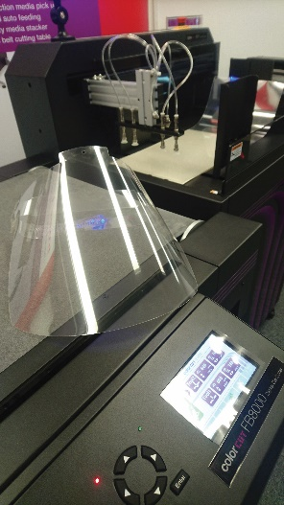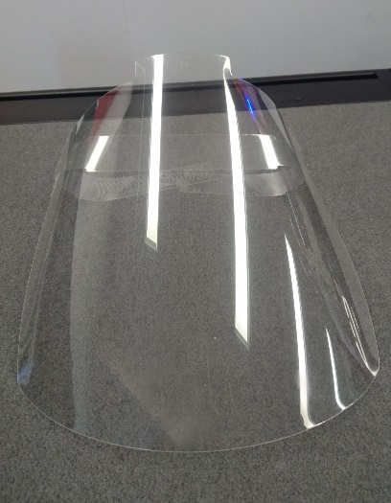
As the global Covid-19 pandemic changes our world, one manufacturer, Intec Printing Solutions has found an innovative way to help printing and finishing companies continue to be relevant in these difficult times - enabling them to supply their clients with products they REALLY need.
Known for manufacturing a range of cutting solutions for label and sheet based products that are typically used by printing companies to make packaging, point of sale, wedding stationery and folders. Intec Printing Solutions is helping printers realise they can do much more than just cut card or label media.
In conjunction with the recently launched FB8000 PRO automated sheet fed cutter, Intec has unveiled a Royalty Free Face Shield cutting design available for download from their website, complete with visor and head band which is ideal for emergency / protective disposable face shields suitable for care homes and the health sector.
Intec has been delighted to partner with Active Window Films (visorshield.co.uk) who are already using Intec cutters and making these face shields for health care workers and have repurposed their production to solve the growing demand for the face shields.
Download the face shield files by clicking here (from the Intec website News section).
What makes the Intec FB8000 PRO highly desirable is that it is fully automated and can cut a visor in up to 25 seconds, enabling almost 1,000 face shields to be made per day. The FB8000 PRO is made for busy organisations that want unattended, automated yet versatile cutting to expand the products they offer customers, key features include an automatic feeder that holds up to 2,000 sheets of media (depending on thickness) from its media stacker and can cut up to 600 micron card or even plastic substrates such as PET, Polypropylene or PVC from 100 micron up to 400 micron. To make the system even more attractive to printing companies, the FB8000 PRO includes a job recognition system that retrieves cut files and cuts the correct job for each sheet loaded.
The FB8000 PRO including the auto feed system and the cutting software is a highly affordable cutter however Intec is offering a subsidy to help companies that wish to use the system to supply face shields. This makes it attractive both now; to provide the much needed emergency PPE supplies for the current crisis while attracting new customers and also keeping business flowing in these difficult time, as well as also providing a fantastically affordable opportunity to acquire one of these versatile cutters to help you retain more customers and improve your profit margins when business returns back to normal.

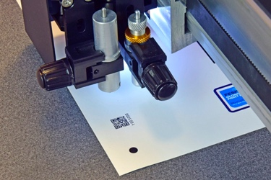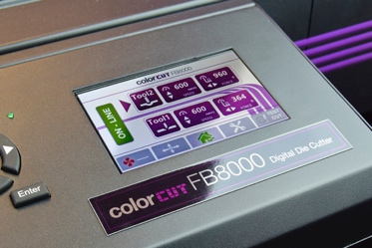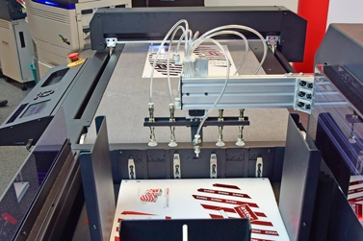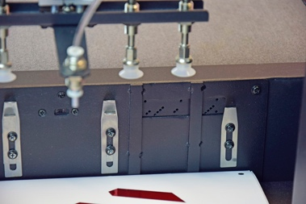
(1) QR code reading for instant cut file retrieval from Job Library. CCD video camera reads SmartMarks to ensure perfect registration. (2) Touchscreen control panel. (3) 4 x pneumatic pick ups for improved media handling. (4) Air blade separation jets in chassis provide faultless media pick up.

The new ColorCut FB8000, in a nutshell…

A digital die cutting system enabling printed sheets to be cut and creased using lines drawn from leading vector graphic design applications. Being digital, sheets can be cut instantly and on-demand, without sending out for dies or to have cutting forms made. Automated functionality enables unattended operation.

The auto sheet feeder enables users to stack up to 25kg of sheets, which are loaded on to the cutting belt using a pneumatic feed system with vacuum pick up fingers and a sophisticated air blade system, to virtually eliminate misfeeds.

The cutter receives the auto fed sheets onto its cutting mat and uses a high-resolution CCD camera to scan registration marks and also read QR codes to identify and automatically retrieve the appropriate cutting file from the ColorCut Pro’s remote job library.
The FB8000 can cut and crease a single sheet through a set number of copies to the entire media stack in the feeder. Even coping with a mixed batch of different jobs, each cut accurately, efficiently and reliably.

Reference materials from the following links, selection of high-resolution images available upon request.

Product video of machine in operation
https://youtu.be/H83DSYAXmWs

Link to brochure:
https://intecprinters.com/wp-content/uploads/2020/01/ColorCut-FB8000-Generation-2-brochure.pdf

Website page:
https://intecprinters.com/products/digital-cutting-devices-for-print-work/automated-flatbed-cutters/

About Intec
Intec Printing Solutions Limited, is the manufacturer and distributor of the global printing and finishing solutions brand, Intec. Founded in 1989 by managing director Ian Melville, the company celebrates its 30th year in 2020 and has their head office in Poole (UK) with an office for the Americas, based in Tampa, Florida. Intec sells digital printing and finishing solutions, worldwide, through an extensive partner network and offers customers unique solutions to expand their print offerings to new market sectors.
Follow Intec Online

Website: www.intecprinters.com Follow us on Twitter: @IntecPrinters Find us on Facebook: Intec Printing Solutions
View us on YouTube: www.youtube.com/intecprinter Join us on LinkedIn: Intec Online
NOTE TO EDITORS: The Intec brand names and products are the intellectual property and copyright of Intec Printing Solutions Limited. All other terms and product names may be trademarks or registered trademarks of their respective owners and are hereby acknowledged.
Contact Information
Terri Winstanley, Intec Printing Solutions Ltd. Phone: +44 (0)1202 845960 Email: marketing@intecprinters.com
ENDS
…………………………………………………………………………………………………………………………………………

