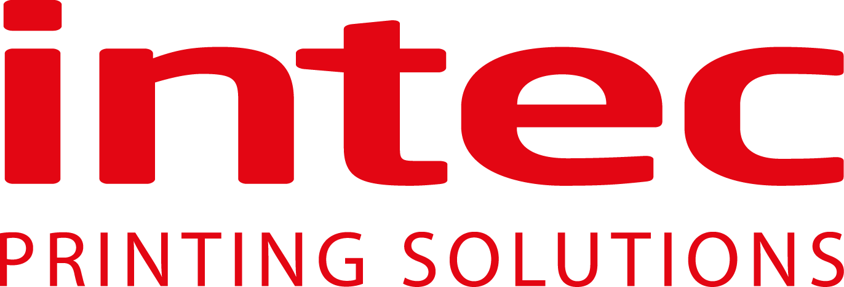 I Press Release
Available for Immediate release
Intec launches an ultra-fast kiss cutter to fully automate label production
United Kingdom, 12 May 2020 – Known for its innovative auto feed cutting solutions, Intec Printing Solutions Limited, releases an ultra-fast label cutter for busy print departments.
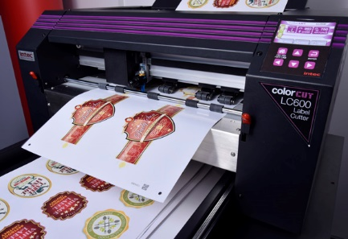

The new ColorCut LC600 ‘on demand’ digital sheet label cutter is designed to provide automatic sheet label cutting for digital print production users. With NO die’s or setup costs users can cut any shape label, in an instant, making this ideal solution for the label and packaging market sectors.
Targeted at busy print departments, seeking complete unattended cutting production, the LC600 combines reliable label sheet feeding with an instant job retrieval system - this ensures effortless, yet precise, kiss cut labels at lightning-fast speeds.
Offering an unparalleled production capability to cut a mixed batch of label jobs, the LC600 can load a sheet of labels and read a QR code to instantly recognise the associated cut file, on every sheet, on the fly. The feeder/stacker can take up to 250 sheets of a varied stack of jobs and cut one after the other, in a seamless and uninterrupted flow and with SmartMark registration, the cutter ensures superb accuracy, every time.
The LC600 is powered by Intec’s renowned ColorCut Pro software that integrates with Adobe® Illustrator® or CorelDRAW® with plug in support. When users create their job, ColorCut Pro applies an auto assigned (editable) QR code to each of the designs and saves the cutting file to the ColorCut Pro Job Library which is automatically retrieved when cutting.

The digital cutting head can apply up to 750g of pressure and cut at up to 960mm per second enabling users to produce either one or indeed hundreds of sheets and thousands of labels. And with its 'Dual Grip' feed system, holds the media during cutting on BOTH sides of the cutting head, enabling it to cut closer to the media edges than most other types of cutter.
Designed with space saving in mind the LC600 sports a retractable media catch tray that slides away when not in use, ensuring that it can easily be accommodated in any print shop.
Mark Baker-Homes, director of product development states, “Intec has developed this really exciting product at a time when label suppliers need to offer an incredibly quick turnaround to companies requiring much needed health and safety labelling”.

Product video of machine in operation
https://youtu.be/I1ZsTp8szJI

Link to brochure:
https://intecprinters.com/wp-content/uploads/2020/05/LC600-BROCHURE-INTEC-EN-FINAL-V2-web.pdf

Website page:
https://intecprinters.com/products/digital-cutting-devices-for-print-work/automated-sheet-label-cutters/

About Intec
Intec Printing Solutions Limited, is the manufacturer and distributor of the global printing and finishing solutions brand, Intec. Founded in 1989 by managing director Ian Melville, the company celebrates its 30th year in 2020 and has their head office in Poole (UK) with an office for the Americas, based in Tampa, Florida. Intec sells digital printing and finishing solutions, worldwide, through an extensive partner network and offers customers unique solutions to expand their print offerings to new market sectors.
Follow Intec Online

Website: www.intecprinters.com Follow us on Twitter: @IntecPrinters Find us on Facebook: Intec Printing Solutions
View us on YouTube: www.youtube.com/intecprinter Join us on LinkedIn: Intec Online
NOTE TO EDITORS: The Intec brand names and products are the intellectual property and copyright of Intec Printing Solutions Limited. All other terms and product names may be trademarks or registered trademarks of their respective owners and are hereby acknowledged.
Contact Information
Terri Winstanley, Intec Printing Solutions Ltd. Phone: +44 (0)1202 845960 Email: marketing@intecprinters.com
ENDS
…………………………………………………………………………………………………………………………………………

