I Press Release
Available for Immediate release
Intec releases new Flatbed cutters
United Kingdom, 27 July 2020 – Known for its innovative cutting solutions, Intec Printing Solutions Limited, releases new flatbed models to its incredibly successful flatbed range.
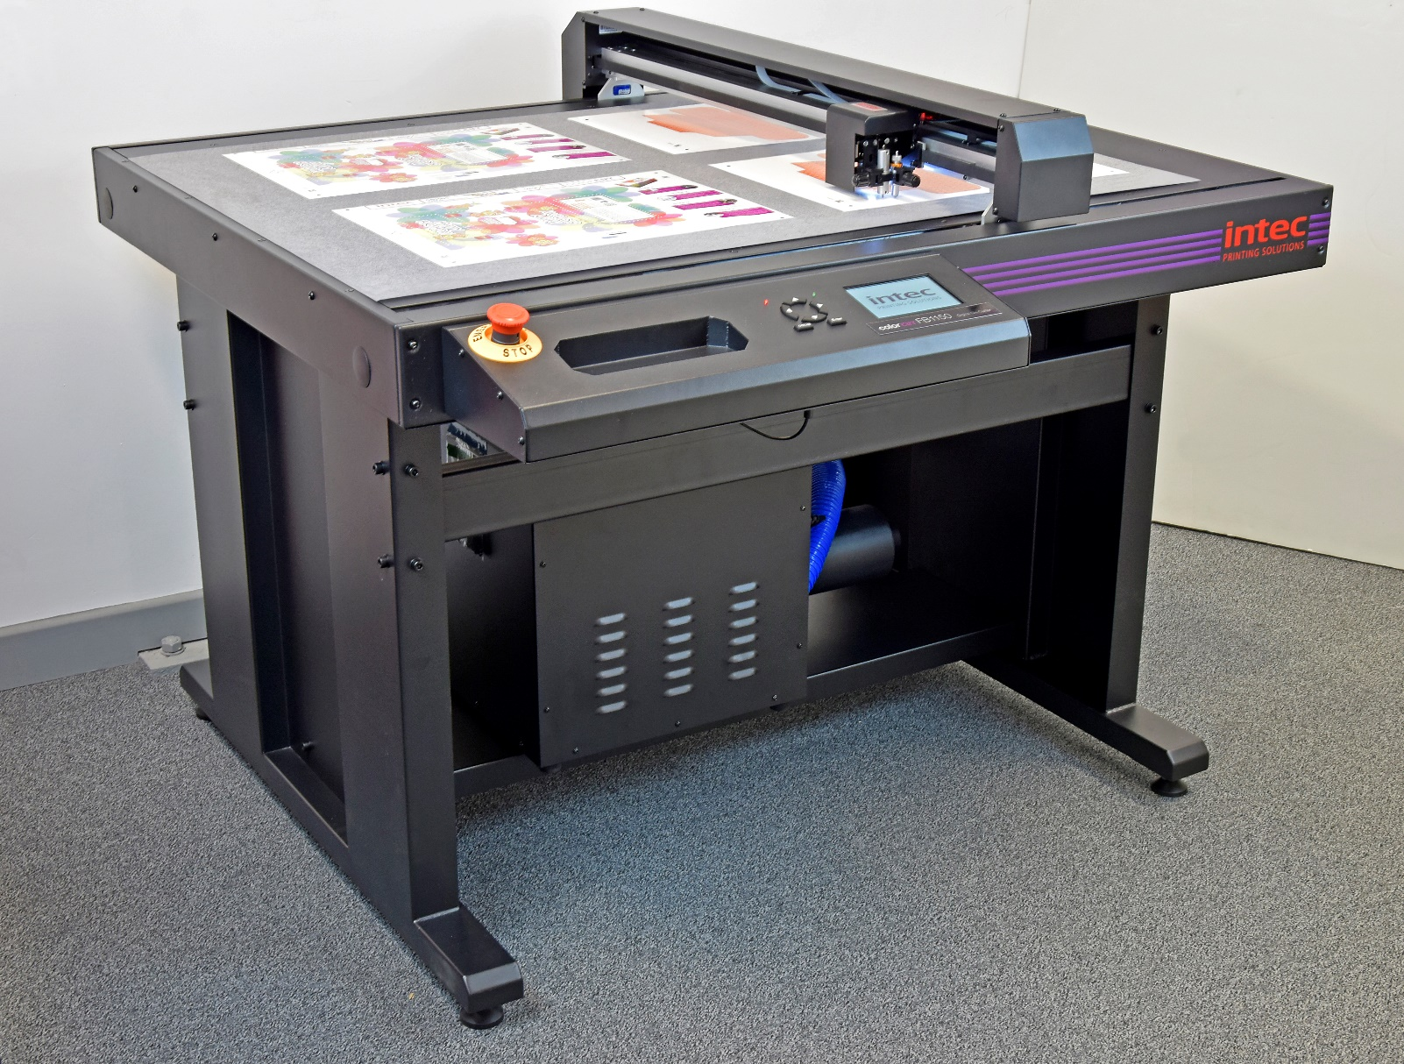

Intec launches a raft of new flatbed models into its digital flatbed cutter range for mid-volume producers, aiming at customers wanting to handle a more diverse range of media for varied applications.
The new flatbeds now offer a much improved user experience via new touch screen controls and the flagship FB1150 comes with an upgraded registration system to include 7th generation ARMS sensing, for faster job retrieval and 300% faster job registration, making it great for multiple sheet cutting.
Offering an unparalleled production capability the flatbeds use either a CCD video camera or optical sensor (model dependent) and can cut mixed sheets, placed together on the cutting table, in a seamless and uninterrupted flow and with SmartMark registration the cutter ensures superb crease and cut accuracy, every time.
Both creasing and cutting capabilities are generated via a multi-tool holder with interchangeable tools, that can apply up to 1kg of pressure, supporting the immediate finishing of packaging, POS, prototypes and kiss-cut labels - with NO die’s or setup costs users can cut any shape, in an instant!
Three new flatbed models; FB550, FB750 and FB1150, cater to a variety of stocks and sizes ranging from 350 x 520mm and up to 740 x 1040mm and can handle paper, boards, synthetic materials, vinyls and kiss cut applications from 0.5mm to 1200 micron, cutting at up to 600mm per second with an SRA3 taking between 30 – 45 seconds per sheet, depending on job complexity.
Cut jobs are instantly recognised with Intec’s unique job retrieval software, ColorCut Pro. ColorCut Pro integrates with Adobe® Illustrator® or CorelDRAW® so users have a smooth transition to creating the necessary cut files. When users create their job, ColorCut Pro applies an auto assigned (editable) barcode or QR code to each of the designs and saves the cutting file to the ColorCut Pro Job Library which is automatically retrieved when cutting. All flatbed models are supplied with a version of ColorCut Pro.
Mark Baker-Homes, Director of product development states; “The launch of the new flatbed range of cutters represents an exciting new phase, in terms of the development of our cutters with a significantly improved user experience through the more responsive and immersive 5 inch touch panel screens. Additionally the 7th generation Vision3 ARMS sensor provides almost instant job recognition and lightning fast registration and alignment, enabling any user to cut jobs, which places the Intec cutters at the top of their class. We are ensuring users faster set up and production times providing the ability to deliver a more on-demand environment for the promotional and packaging market”.

Most print environments struggle with enough space to place a new piece of equipment so the flatbeds are designed to use minimal floor space, ensuring that they can easily be accommodated in any print shop with the smaller footprint table’s ideal for packaging sample making and mocks ups to improve design and approval processes.

Product video of machine in operation:
https://youtu.be/CEIQG_qM7uc

Link to brochure: https://intecprinters.com/wp-content/uploads/2020/06/COLORCUT-FLATBED-JUNE-2020-EN-WEB.pdf

Website page:
https://intecprinters.com/products/digital-cutting-devices-for-print-work/digital-flatbed-cutters/

About Intec
Intec Printing Solutions Limited, is the manufacturer and distributor of the global printing and finishing solutions brand, Intec. Founded in 1989 by managing director Ian Melville, the company celebrates its 30th year in 2020 and has their head office in Poole (UK) with an office for the Americas, based in Tampa, Florida. Intec sells digital printing and finishing solutions, worldwide, through an extensive partner network and offers customers unique solutions to expand their print offerings to new market sectors.
Follow Intec Online

Website: www.intecprinters.com Follow us on Twitter: @IntecPrinters Find us on Facebook: Intec Printing Solutions
View us on YouTube: www.youtube.com/intecprinter Join us on LinkedIn: Intec Online
NOTE TO EDITORS: The Intec brand names and products are the intellectual property and copyright of Intec Printing Solutions Limited. All other terms and product names may be trademarks or registered trademarks of their respective owners and are hereby acknowledged.
Contact Information
Terri Winstanley, Intec Printing Solutions Ltd. Phone: +44 (0)1202 845960 Email: marketing@intecprinters.com
ENDS
…………………………………………………………………………………………………………………………………………

