I Press Release
Available for Immediate release
Intec upgrades its FB750 flatbed cutter
United Kingdom, 21 September 2020 – Intec, who recently refreshed their range of flatbed cutters, further improves the FB750 model by now offering it with CCD Camera for QR Code reading for instant job recognition.
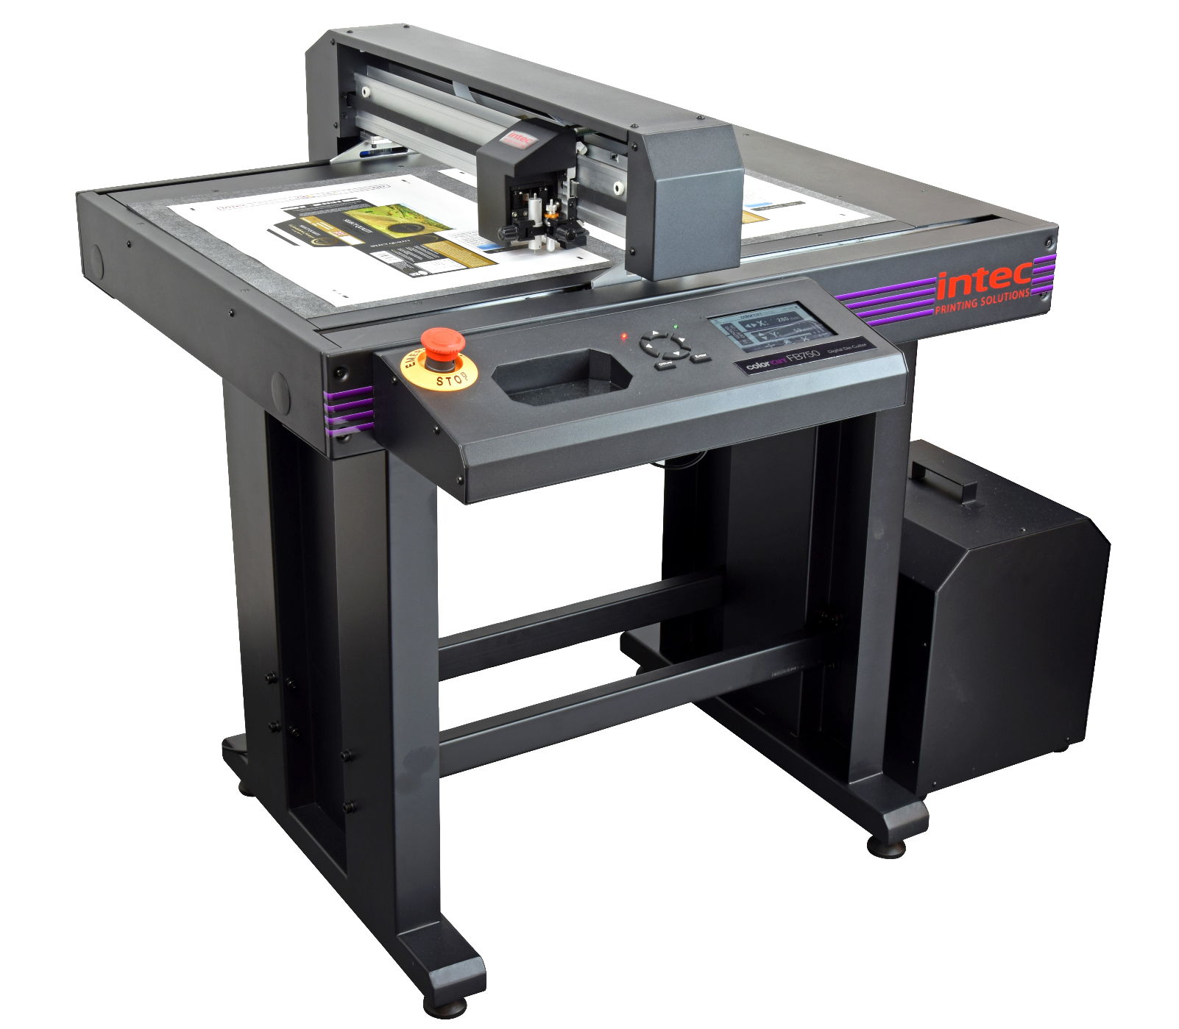

The new FB750 flatbeds will now offer a much improved user experience with an upgraded registration system to include QR Code reading and 7th generation Vision3 ARMS sensing, providing faster job retrieval and 300% faster job registration.
Aimed at light production applications and producers wanting to handle a more diverse range of media for varied applications, the FB750 offers an unparalleled production capability with its new CCD video camera. A printed QR code and page registration SmartMarks are read at lightning speeds for the instant retrieval the associated cut file and providing perfect cut registration.
The cutting table can handle sheet sizes of B2 and larger and with the ability to place 2 x SRA3 sheets next to each other or 4x SRA4, the flatbed offers a wide use for paper, boards, synthetic materials, vinyl decals and kiss cut materials from 0.5mm to 1200 micron.

With no costly die’s or setup charges users can cut any shape, in an instant! An SRA3 takes between 30-40 seconds per sheet, to cut and crease, depending on job complexity with cutting and creasing generated via a multi-tool holder with interchangeable tools. Up to 1kg of pressure can be applied to the individual tools with the flatbed supporting the immediate finishing of packaging, POS, prototypes and kiss-cut labels!

Terri Winstanley, product and marketing manager states; “With this further development and being able to handle sheet sizes up to B2 and larger, the FB750 enables users to achieve higher productivity with less time taken reading sheets. And with its incredibly aggressive price point we are confident that the FB750 will continue to be an extremely popular model within the extensive ColorCut flatbed range”.
Designed to use minimal floor space, the FB750 can easily be accommodated in any print shop.

Website page:
https://intecprinters.com/products/digital-cutting-devices-for-print-work/digital-flatbed-cutters/colorcut-fb750-b2-flatbed-cutter/

About Intec
Intec Printing Solutions Limited, is the manufacturer and distributor of the global printing and finishing solutions brand, Intec. Founded in 1989 by managing director Ian Melville, the company celebrates its 30th year in 2020 and has their head office in Poole (UK) with an office for the Americas, based in Tampa, Florida. Intec sells digital printing and finishing solutions, worldwide, through an extensive partner network and offers customers unique solutions to expand their print offerings to new market sectors.
Follow Intec Online

Website: www.intecprinters.com Follow us on Twitter: @IntecPrinters Find us on Facebook: Intec Printing Solutions
View us on YouTube: www.youtube.com/intecprinter Join us on LinkedIn: Intec Online
NOTE TO EDITORS: The Intec brand names and products are the intellectual property and copyright of Intec Printing Solutions Limited. All other terms and product names may be trademarks or registered trademarks of their respective owners and are hereby acknowledged.
Contact Information
Terri Winstanley, Intec Printing Solutions Ltd. Phone: +44 (0)1202 845960 Email: marketing@intecprinters.com
ENDS
…………………………………………………………………………………………………………………………………………

