I Press Release
For immediate release - 1st June 2021

Intec launches a truly revolutionary new type of automated cutter – filling a massive gap in the print finishing marketplace.
United Kingdom, 14th May 2021 – Known for its innovative auto feed cutting solutions, Intec Printing Solutions Limited, releases the ColorCut SC5000 Sheet Cutter.
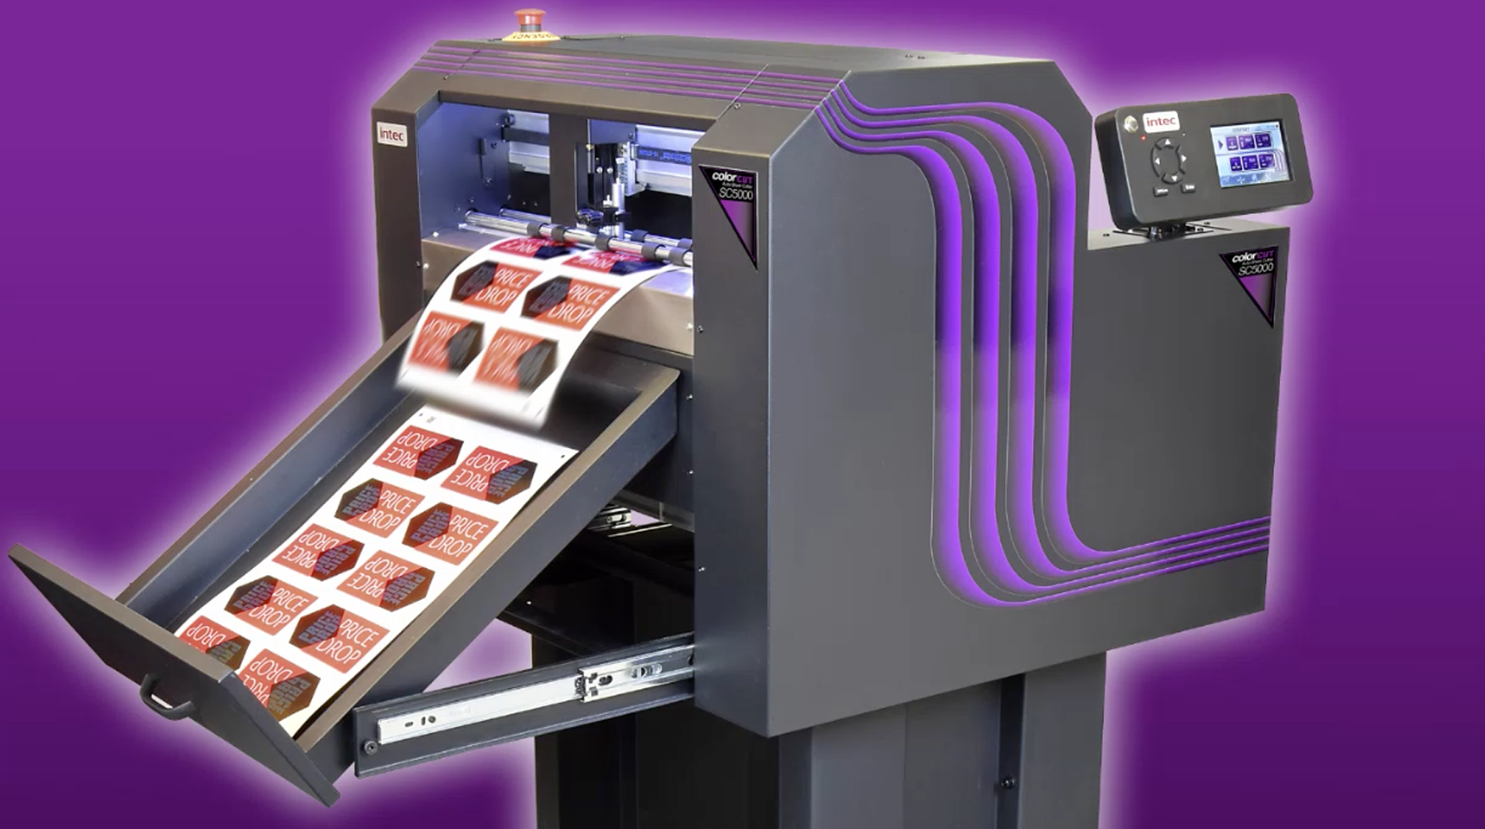

ColorCut SC5000. Automated sheet cutting & creasing, for lightweight card, packaging, P.O.S and kiss-cut sheet labels

ColorCut SC5000 is a truly revolutionary new type of automated cutter – filling a massive gap in the print finishing marketplace.
There is currently no other model available worldwide, that offers both; 100% reliable high-volume auto feeding, along with a dual tool head for both cutting and creasing. The SC5000 does this and is a seriously professional and productive machine, that even weighs-in at around the same low price-point as its less competent nearest rival!

Blending flatbed and sheet fed technologies, the all new ColorCut SC5000 is perfect for fast, automated production of both die-cutting and creasing light-weight card for packaging and P.O.S, paper and polyester projects – as well as kiss-cut sheet label production.

Head-and-shoulders above the competition
The all new ColorCut SC5000 has been developed by Intec from the ground up. Listening to print professionals in the field, Intec has produced a top-quality digital sheet cutter that hugely out-ranks the fairly limited capabilities of sheet cutters in its class. Firstly, by offering a revolutionary new suction-operated belt-feeding mechanism, that flawlessly feeds from its cavernous 1,000 sheet media stacker. Secondly, at the sharp end, the dual tool cutting head features a double-ended creasing tool alongside the cutting tool. This enables the SC5000 to both cut and crease. These two aspects alone, (not to mention its low price point), put the SC5000 head-and-shoulders above any device in this print finishing market space!
Fully automated and on demand
SC5000 is fully automated and can be set to provide complete unattended operation. Similarly, being an ‘on demand’ digital sheet cutter with no dies or setup costs – the user can easily perform a one-off sample, or develop batches of prototypes or cut thousands on a production run. Targeted for busy print departments, seeking an affordable, high-capacity device for complete unattended cutting production.
High-capacity and ultra-reliable feeding.
The SC5000 features a high-capacity 1,000 sheet media stacker which can feed a constant demand. The revolutionary new suction belt system draws upon the media stack and offers faultless feeding! In conjunction with an LED sensor, the top sheet in the stack is separated from the other sheets by an airbladeLITE® system, similar to that used on Intec’s popular ColorCut FB8000 flatbed cutter. The suction feeding continuous belt drive mechanism is automatically synchronised to lower and pick the top sheet when offered – and presents it on to the cutting strip. This system has been designed to provide unattended operation with particular attention paid to the feeding of popular media such as; card, vinyl labels, polyesters and even tricky laminated sheets.
Automatic cut file retrieval.
With the arrival of the given printed sheet at the cutting strip, the live CCD video camera automatically reads the QR coded sheet and instantly retrieves the associated digital cut file. The predetermined cutting tasks are communicated to the cutting head for exact and precise execution of the tasks required. There is therefore no need for a highly skilled machine operator.
When creating vector artworks on PC or Mac, in a networked design studio, ColorCut Pro is used to add an auto assigned (editable) QR code to each design, whilst auto-saving the cutting file to the ColorCut Pro Job Library – this becomes the cut file that the networked SC5000 retrieves upon reading the QR code.
Loves mixed jobs in the stack.
Offering an unparalleled production capability to cut a mixed batch of jobs, the SC5000 will seamlessly retrieve the associated cut files for an unlimited number of different jobs in the stack. This is totally instant and with zero delay, enabling a seamless and uninterrupted flow.
Total pinpoint accuracy.
When applying the QR code during the artwork stage, ColorCut Pro also adds a series of marks in the corners of the sheet, this is a four-point SmartMark registration system, enabling the cutter to ensure superb accuracy with the cut lines and also compensate for any print stretch or skew.
Proprietary vector app integration.
Intec’s renowned ColorCut Pro software ships with all ColorCut devices and integrates with Adobe® Illustrator® or CorelDRAW® with plug in support. All desired tasks such as; first cut, score, perforate, final cut etc, can be conveyed by the colour applied to its vector line. This data is all captured within the dedicated QR code and subsequently read by the cutter. If required, design content can be changed and the sheets reprinted – without the need to edit or remake the cut file. In fact, the cut files can be used for any subsequent jobs of the same shape, which feature different printed design content – alternative versions and sets, for example.

Crease and cut and fast!
The digital cutting head can apply a force of up to 750g of pressure and cut and crease simultaneously at speeds of up to 960mm per second, enabling users to produce either one or indeed hundreds of sheets and thousands of items.
Grip and drive.
The unique ColorCut ‘Grip and Drive’ dual roller system, holds the sheet media during cutting on BOTH sides of the cutting head, enables the SC5000 to cut closer to the media edges than most other types of sheet cutter.
Compact and fully-mobile.
Designed with space saving in mind, the free-standing and fully-mobile SC5000 also features a retractable media catch tray that slides away when not in use, ensuring that its sub-1sq mtr footprint can easily be accommodated in any print shop.
Word from Intec management: Mark Baker-Homes, Intec director of product development states: “The SC5000 is quite simply, a stunningly cost-effective automated sheet fed digital cutter, for cut-through of any shape on lightweight card, paper and even the kiss-cutting of sheet labels. We would love to show off the full range of impressive features through a face-to-face personal – or even virtual, demonstration…"

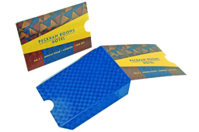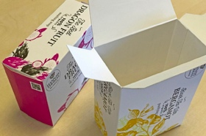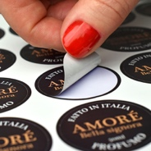

SC5000 is perfect for cutting and creasing; swing tickets, mirror hangers, hotel key card pouches, shelf wobblers, product cartons and gift boxes, and of course sheet labels – all cut to any shape desired.

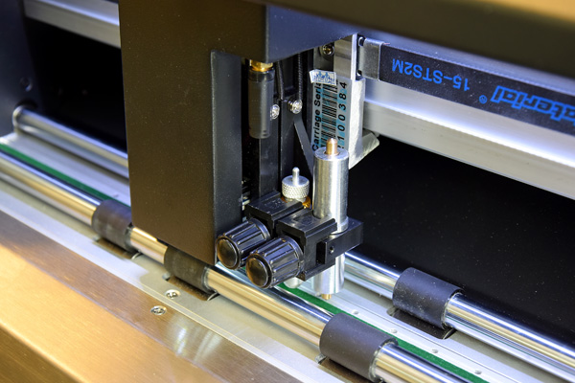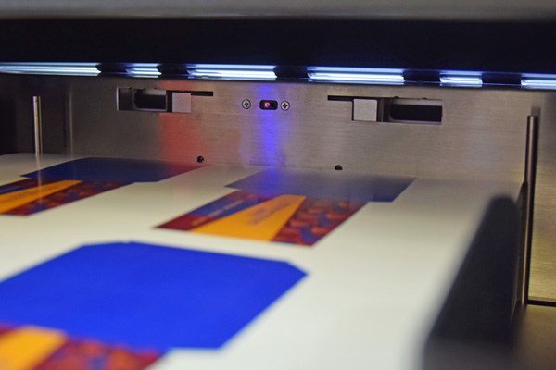
Dual tool head for creasing as well as cutting LED stack top sensor and AirlbladesLITE®

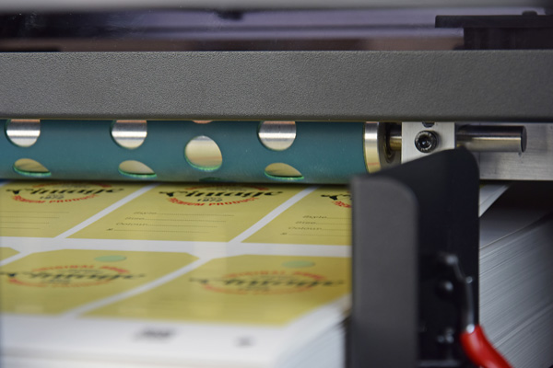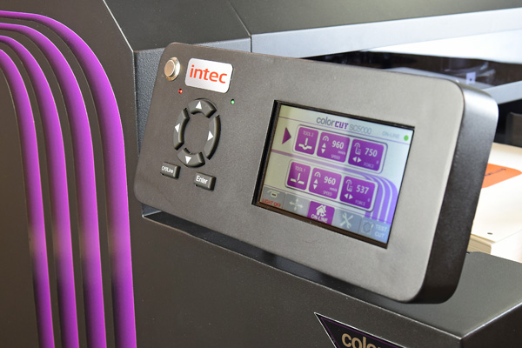
Revolutionary suction media pick up belt gives faultless feeding Articulated and immersive control panel

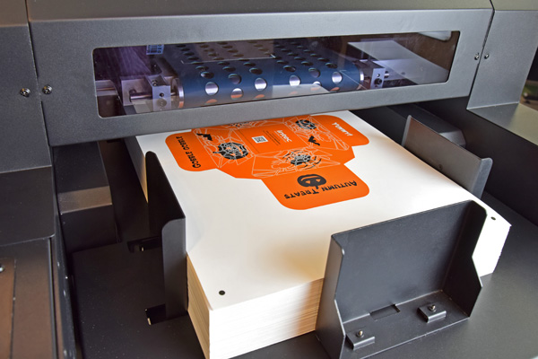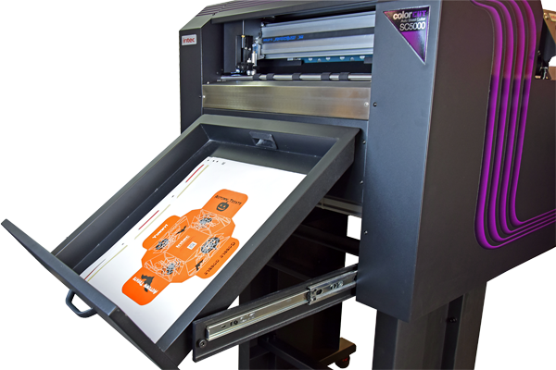
Cavernous high-capacity sheet stack, auto-feeder Media catch tray folds away when not in use, to make compact footprint
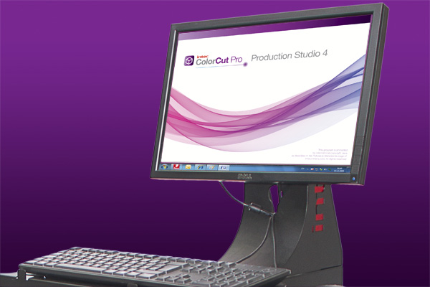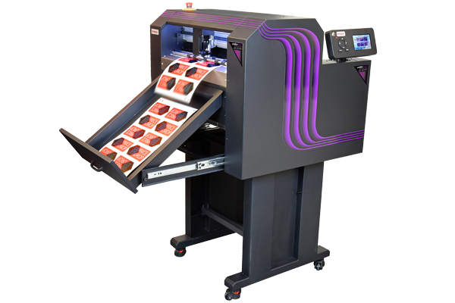
ColorCut Pro software enables full control over tasks and workflow Free-standing and full mobile ColorCut SC5000 sheet cutter

Further information

Product video of machine in operation
https://youtu.be/Arkj039rAQE

Link to brochure:
https://intecprinters.com/wp-content/uploads/2021/05/SC5000-BROCHURE-INTEC-EN-web.pdf

Website page:
https://intecprinters.com/products/digital-cutting-devices-for-print-work/automated-cutters/auto-sheet-cutters/

Image requests:
marketing@intecprinters.com

About Intec
Intec Printing Solutions Limited, is the manufacturer and distributor of the global printing and finishing solutions brand, Intec. Founded in 1989 by managing director Ian Melville, the company celebrated its 30th year in 2020 and has their head office in Poole (UK) with an office for the Americas, based in Tampa, Florida. Intec sells digital printing and finishing solutions, worldwide, through an extensive partner network and offers customers unique solutions to expand their print offerings to new market sectors.

Follow Intec Online

Website: www.intecprinters.com Follow us on Twitter: @IntecPrinters Find us on Facebook: Intec Printing Solutions
View us on YouTube: www.youtube.com/intecprinter Join us on LinkedIn: Intec Online
NOTE TO EDITORS: The Intec brand names and products are the intellectual property and copyright of Intec Printing Solutions Limited. All other terms and product names may be trademarks or registered trademarks of their respective owners and are hereby acknowledged.
Contact Information
Terri Winstanley, Intec Printing Solutions Ltd. Phone: +44 (0)1202 845960 Email: marketing@intecprinters.com

ENDS
…………………………………………………………………………………………………………………………………………

