I Press Release
For immediate release – 4th January 2022

Intec launches premium, fast and productive, automatic digital die-less flatbed cutter.
United Kingdom, 4th January 2022 – Known for its innovative auto feed cutting solutions, Intec Printing Solutions Limited, releases the ColorCut FB9000PRO Automatic Digital Die Cutter as its flagship flatbed cutting model.
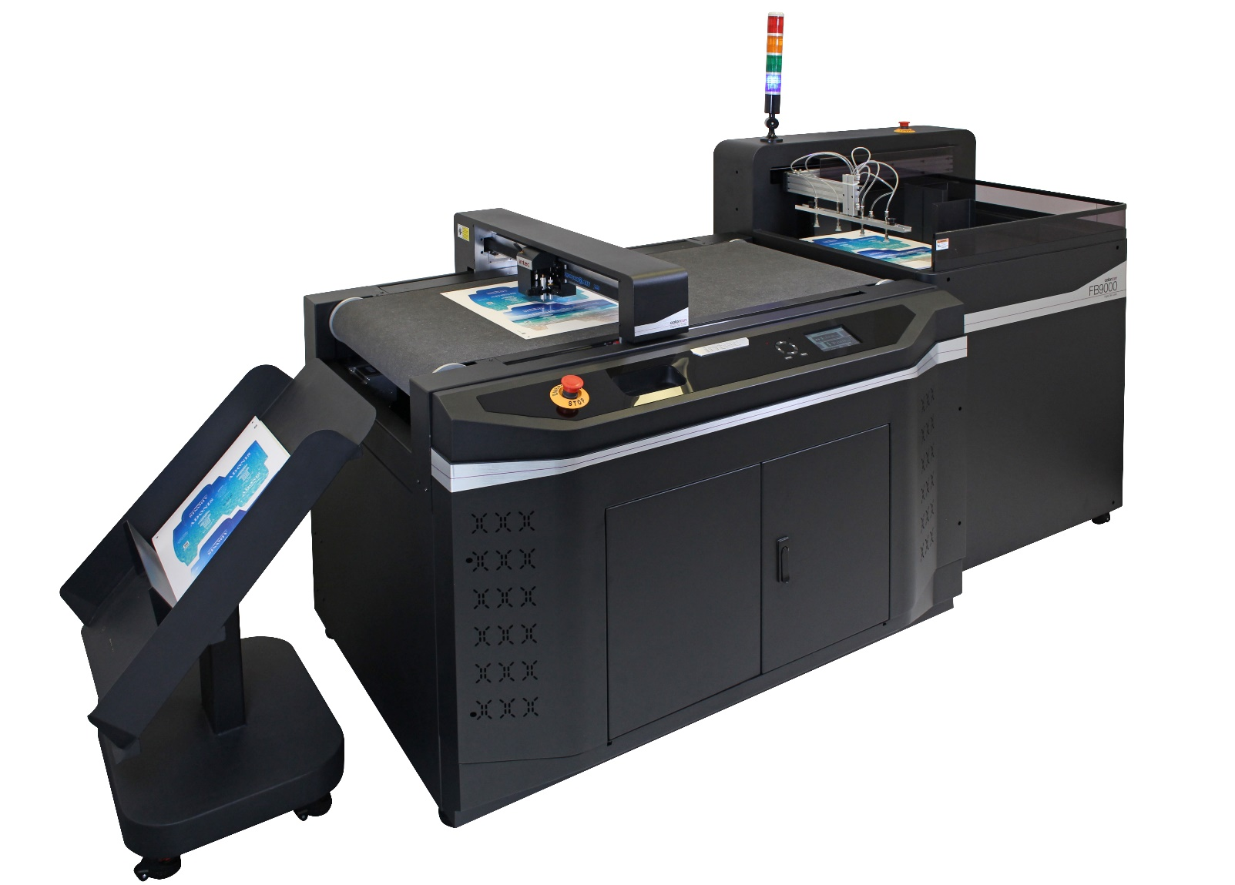

ColorCut FB9000PRO. Automated sheet cutting & creasing, for up to 1,000 micron FB Board / card, packaging, P.O.S and kiss-cut sheet labels.

Bigger and faster – the new FB9000PRO lands itself right at the top of Intec’s ColorCut product offering and becomes the new flagship model through its impressive new features! By combining cutting, creasing, perforating and scoring in a single pass ensures that the FB9000PRO offers rapid, automated and unattended production for the creation of packaging and P.O.S, paper, synthetic projects and kiss-cut sheet label production. The system is completed with a 2,000 auto feeder/stacker, vacuum suction conveyor belt cutting table and media collection tray to offer true unattended capability.

Mark Baker-Homes, director of business development states, “We are incredibly excited to introduce the FB9000PRO into our very successful ColorCut flatbed cutter range. This product offers a quantum leap in speed and functionality, as well as bringing new styling cues that will permeate across our ColorCut range over the coming year. Our new flagship model ensures any business, that wants to bring unattended quality cutting automation in-house, can do so with confidence.”
The FB9000PRO cutter.
Rapidly processing jobs at speeds of up to 1,200mm/s with an SRA3 sheet cut in 15-45 seconds (depending on file complexity), the FB9000PRO can handle a variety of media types up to 1,000 micron thick including folding box board, card, paper, synthetics, soft boards, vinyl and label stocks and large sheet sizes up to 550mm x 850mm.

Its dual tool head provides separate cutting and creasing tools that operate independently of each other to reduce operation time and improve productivity. The cutting tool applies a class-leading 1.2kg of cutting pressure to achieve crisp cuts on up to 1,000 micron media and an industry first for this type of cutter of 1.5kg creasing pressure, to achieve deep, clean creases. Productivity is further enhanced with the ability to specify different speed modes for ‘blended’ or multi speed cut and crease operations on the same job.

Using QR codes for cut file recognition, the cutters CCD camera quickly reads the code to retrieve the printed sheets associated cut file, and four corner marks to ensure accuracy of cut and crease with the printed artwork and compensate for any sheet placement skew or print stretch. This function also enables the operator to instantly view the job on screen and set the desired cutting features from the systems material database. This means that different aspects of the file can have different treatments applied to them and also predetermine the order they are worked on.

The cutter is driven using the Production Studio package (included with the system), which is part of Intec’s acclaimed ColorCut Pro software suite. This can be used as a stand-alone application with the cutter or as part of a networked solution when used in conjunction with Intec’s ColorCut Pro Server Station. The ColorCut Pro software suite offers sophisticated features with Job Library Manager workflow application and the new Template Maker application for producing vector box templates, to load into Adobe Illustrator or CorelDRAW, for use with the cutter.

High speed sheet feeding.
The auto sheet feeder provides exceptional pneumatic efficiency and material handling to deliver a solution which is perfectly synchronized with the FB9000’s continuous conveyor cutting belt. Accommodating both landscape and portrait feed orientations, the feeders pick-up arm is easily adjusted to accommodate wide or narrow media.

The cavernous media stacker is easily lowered to load up to 2,000 SRA3 sheets (25Kg) or a stack height of up to 22.5cm and raises simultaneously as each sheet is fed, from the top of the stack, to offer true unattended production.

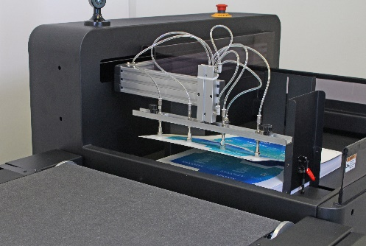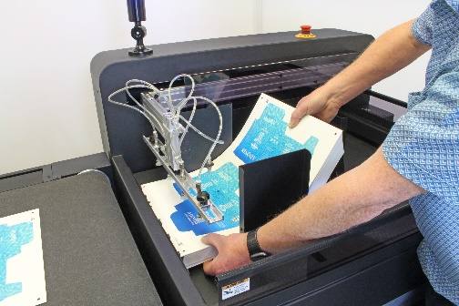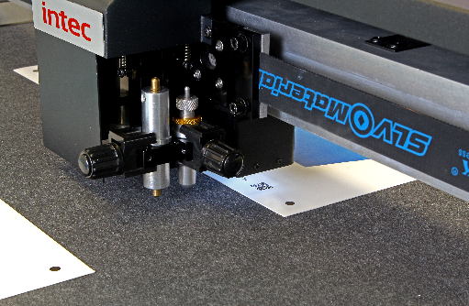
Pneumatic feed with adjustable feeder arm Stack up to 2,000 sheets, 25Kg/22.5cm media QR code and page mark reading

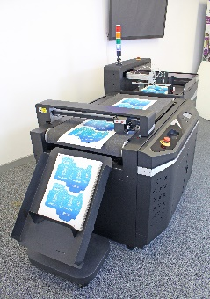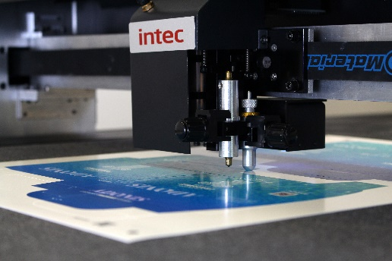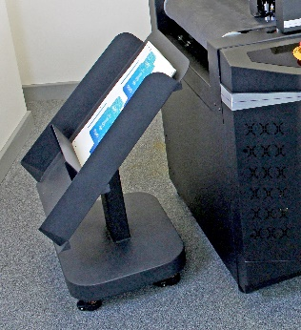
Continuous conveyor cutting belt Independent cutting & creasing dual tool head Collection tray – modular and moveable

Further information

Product video of machine in operation
https://youtu.be/M5K-xu9wwLM

Link to brochure:
https://intecprinters.com/wp-content/uploads/2021/12/FB9000PRO_UK_web-2.pdf

Website page:
https://intecprinters.com/products/digital-cutting-devices-for-print-work/automated-cutters/colorcut-fb9000pro-automatic-flatbed-cutter/

Image requests:
marketing@intecprinters.com

About Intec
Intec Printing Solutions Limited, is the manufacturer and distributor of the global printing and finishing solutions brand, Intec. Founded in 1989 by managing director Ian Melville, the company celebrated its 30th year in 2020 and has their head office in Poole (UK) with an office for the Americas, based in Tampa, Florida. Intec sells digital printing and finishing solutions, worldwide, through an extensive partner network and offers customers unique solutions to expand their print offerings to new market sectors.

Follow Intec Online

Website: www.intecprinters.com Follow us on Twitter: @IntecPrinters Find us on Facebook: Intec Printing Solutions
View us on YouTube: www.youtube.com/intecprinter Join us on LinkedIn: Intec Online
NOTE TO EDITORS: The Intec brand names and products are the intellectual property and copyright of Intec Printing Solutions Limited. All other terms and product names may be trademarks or registered trademarks of their respective owners and are hereby acknowledged.
Contact Information
Terri Winstanley, Intec Printing Solutions Ltd. Phone: +44 (0)1202 845 960 Email: marketing@intecprinters.com

ENDS
…………………………………………………………………………………………………………………………………………

