I Press Release
For immediate release – 1st May 2022

Intec launches NEW B2 digital flatbed cutter model, the FB775.
United Kingdom, 1st May 2022 – Powerful, fast and compact – Intec’s new B2 and larger, digital flatbed cutter, the FB775 is available now!
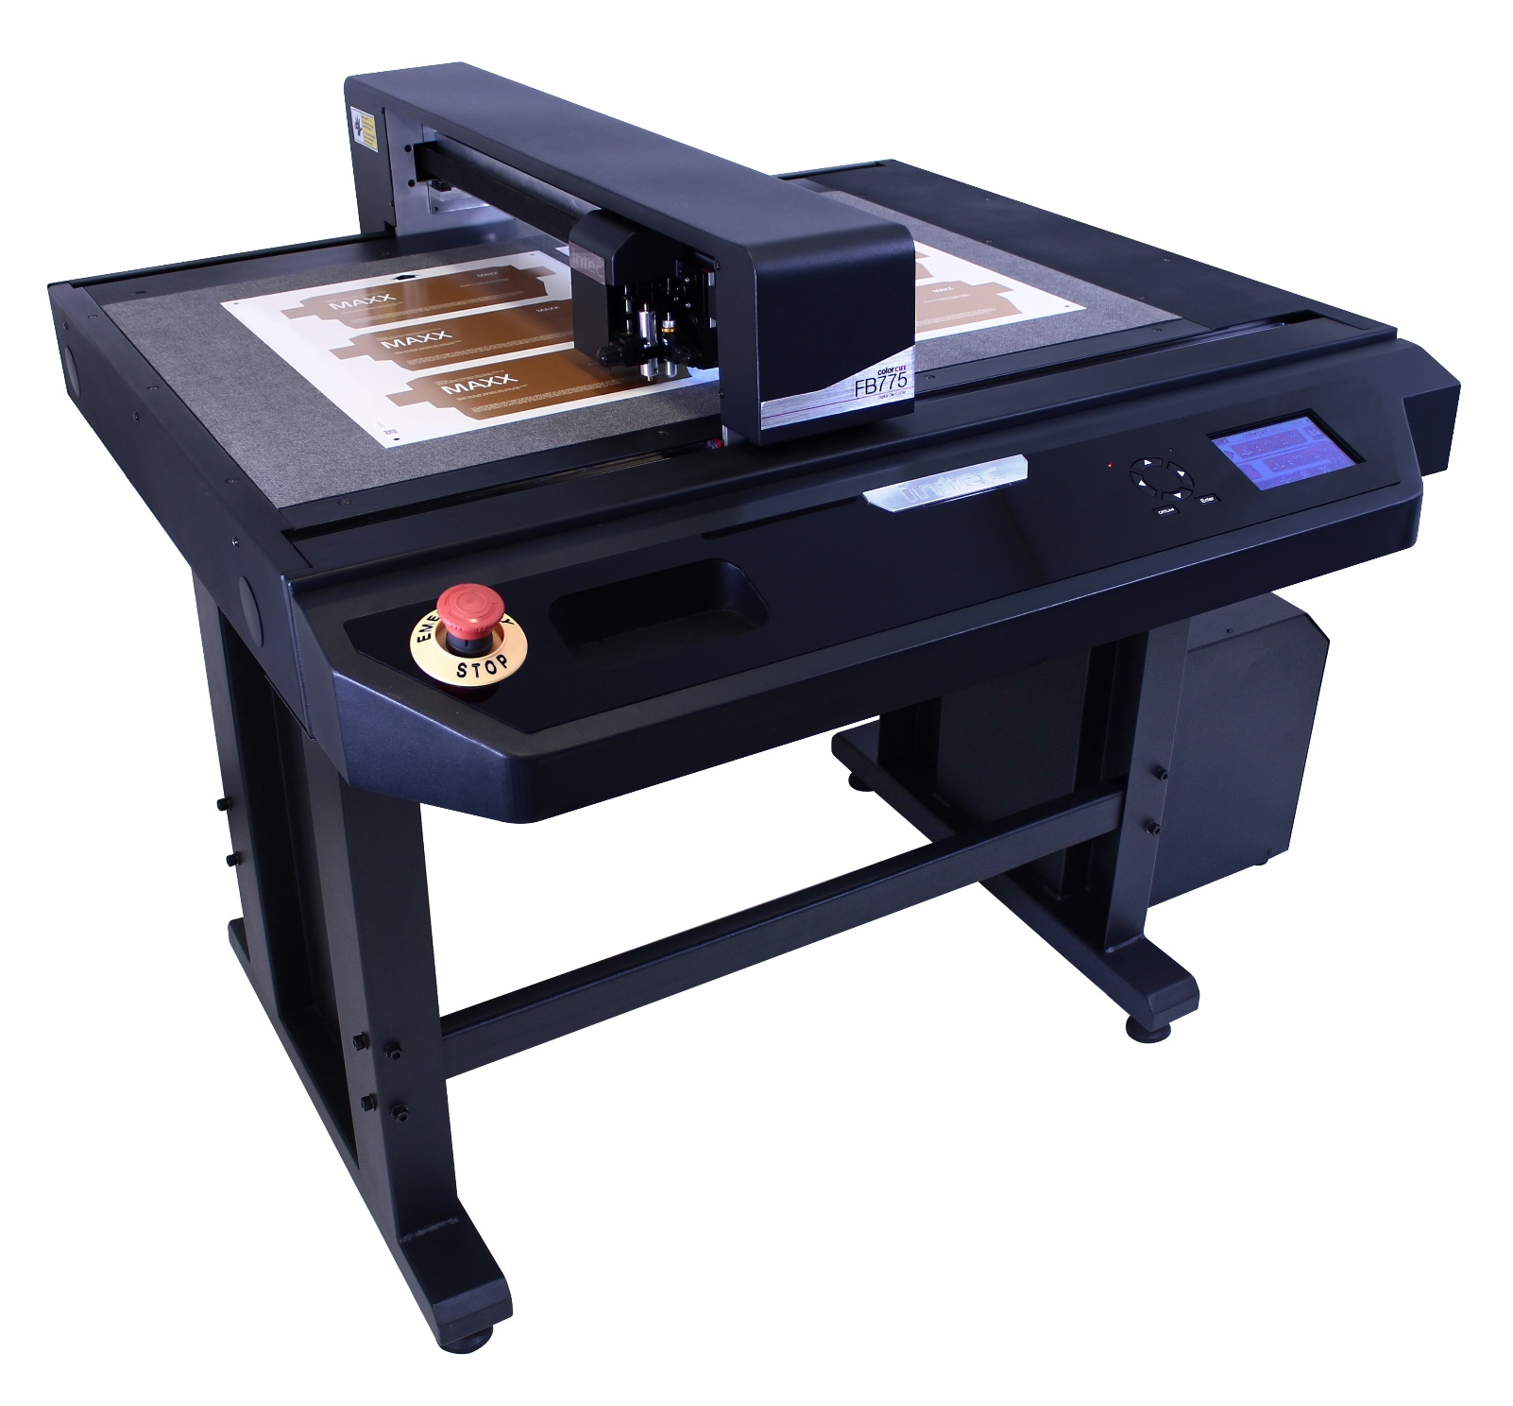

Intec ColorCut FB775 sheet cutting & creasing, for up to 1,000 micron Folding Box Board / card, packaging, P.O.S, design sampling and prototyping as well as kiss-cut sheet labels.

Designed in the UK, beautifully engineered, totally accurate and highly affordable.
Taking its capability and premium styling cues from the newly launched Generation 4 series of Intec ColorCut flatbed cutters, the new FB775 offers exceptionally high-speed cutting and powerful, crisp creasing - making it an incredibly versatile and compact digital die cutting solution for digital print finishing.

The new FB775 offers impressive production capabilities and features for light to medium digital print finishing of two-and three-dimensional items by offering cutting and creasing of virtually any form of print, from cardboard packaging for high-end products and protective cartons, to synthetic point-of-sale and kiss-cut adhesive labels on up to B2 and larger sheet sizes. And because there are no expensive, conventional cutting dies – its all digital - the ability to produce single items, on demand, makes the flatbed perfect for design and cutter sampling as well as prototyping on up to 1,000 micron thick media.

Whilst the cutter sports a same time cutting and creasing dual tool head, with pressures of up to 1.5kgf for creasing and 1.2kgf for cutting, it’s the cutters ability to use its revolutionary ‘blended speed’ mode technology that sets it apart from the competition. With 3 speed modes available, cut and crease actions can be set to; high definition for intricate work, standard mode for mixed shape jobs and fast for straight line action!

The FB775 cutter.
Rapidly processing jobs at speeds of up to 1,200mm/s with an SRA3 sheet cut in 15-45 seconds (depending on file complexity), the FB775 can handle a variety of media types up to 1,000 micron thick including folding box board, card, paper, synthetics, soft boards, vinyl and label stocks and large sheet sizes up to 580mm x 800mm with an effective cutting area of 480 x 715mm.

With a large cutting table, the FB775 can handle B2 folders, and larger sheets. However, it’s the combination of its quick cut file retrieval along with the ability to place 2 x SAR3 sheets next to each other (or 4 x A4 size), which enables users to achieve higher productivity. The FB775 comes with an upgraded registration system to include 8th generation ARMS sensing, for blisteringly fast job file retrieval and job mark registration, making it great for multiple sheet cutting; the Vision3 CCD camera will automatically search and find the position of each sheet for precision cutting.

Terri Winstanley, product and marketing manager states; “The new FB775 is a really powerful yet compact digital die cutter providing accurate and fast production efficiency for any business requiring digital finishing. Anyone who uses it can cut and crease a wide range of materials and fast! However, it’s not all about speed – this model also offers our blended speed modes, so you can cut really fast on the straights and use the high-definition setting for those intricate cuts, all on the same job at the same time! And being able to handle B2 and larger sheets, the FB775 provides the user increased productivity with a small footprint device. We are confident that at its incredibly aggressive price point, the FB775 will be an extremely popular model within the extensive Intec ColorCut flatbed range”.

Bespoke, market-leading software brings many advanced features to aid design and production.
The cutter is driven using the ColorCut Production Studio package (included with the system), which is part of Intec’s acclaimed ColorCut Pro software suite. This can be used as a stand-alone application with the cutter or as part of a networked solution when used in conjunction with Intec’s ColorCut Pro Server Station. The ColorCut Pro software suite offers sophisticated features with Job Library Manager workflow application and the new Template Maker application for producing vector box templates, to load into Adobe® Illustrator® or CorelDRAW®, for use with the cutter. Artworkers also now have a great new feature within the software plug in - create instant reverse crease and cut lines by the click of a button for creasing jobs from the rear.

Designed to use minimal floor space, the FB775 can easily be accommodated in any print finishing environment.

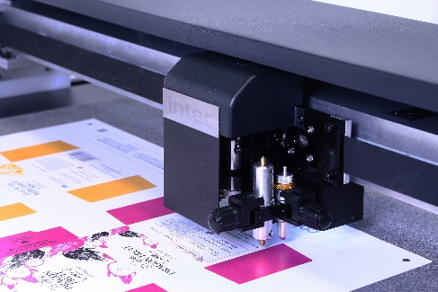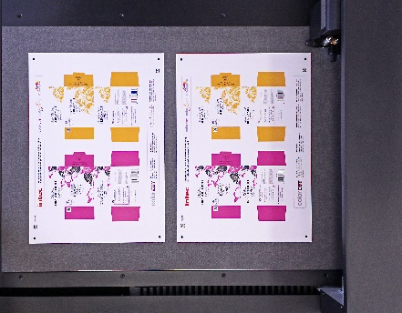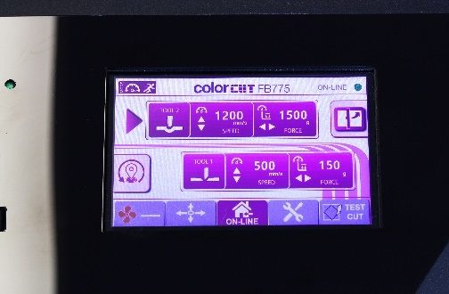
QR code and mark reading/dual tool head Productivity cutting table Interactive Touch Screen

Further information

Product video of machine in operation
https://youtu.be/IANl4SjT2cs

Link to brochure:
https://intecprinters.com/wp-content/uploads/2022/04/CC-Flatbeds-FB1175-FB775-FB550-EN-web.pdf

Website page:
https://intecprinters.com/products/digital-cutting-devices-for-print-work/digital-flatbed-cutters/colorcut-fb775-b2-flatbed-cutter/

Image requests:
marketing@intecprinters.com

About Intec
Intec Printing Solutions Limited, is the manufacturer and distributor of the global printing and finishing solutions brand, Intec. Founded in 1989 by managing director Ian Melville, the company celebrated its 30th year in 2020 and has their head office in Poole (UK) with an office for the Americas, based in Tampa, Florida. Intec sells digital printing and finishing solutions, worldwide, through an extensive partner network and offers customers unique solutions to expand their print offerings to new market sectors.

Follow Intec Online

Website: www.intecprinters.com Follow us on Twitter: @IntecPrinters Find us on Facebook: Intec Printing Solutions
View us on YouTube: www.youtube.com/intecprinter Join us on LinkedIn: Intec Online
NOTE TO EDITORS: The Intec brand names and products are the intellectual property and copyright of Intec Printing Solutions Limited. All other terms and product names may be trademarks or registered trademarks of their respective owners and are hereby acknowledged.
Contact Information
Terri Winstanley, Intec Printing Solutions Ltd. Phone: +44 (0)1202 845 960 Email: marketing@intecprinters.com

ENDS
…………………………………………………………………………………………………………………………………………

