I Press Release
Immediate release

New Intec SC6000 auto-feeding digital die-cutter for lightweight packaging and label production.
United Kingdom, 27th February 2023 – Known for its innovative auto feed cutting solutions, Intec Printing Solutions Limited, releases the ColorCut SC6000 Sheet Cutter.
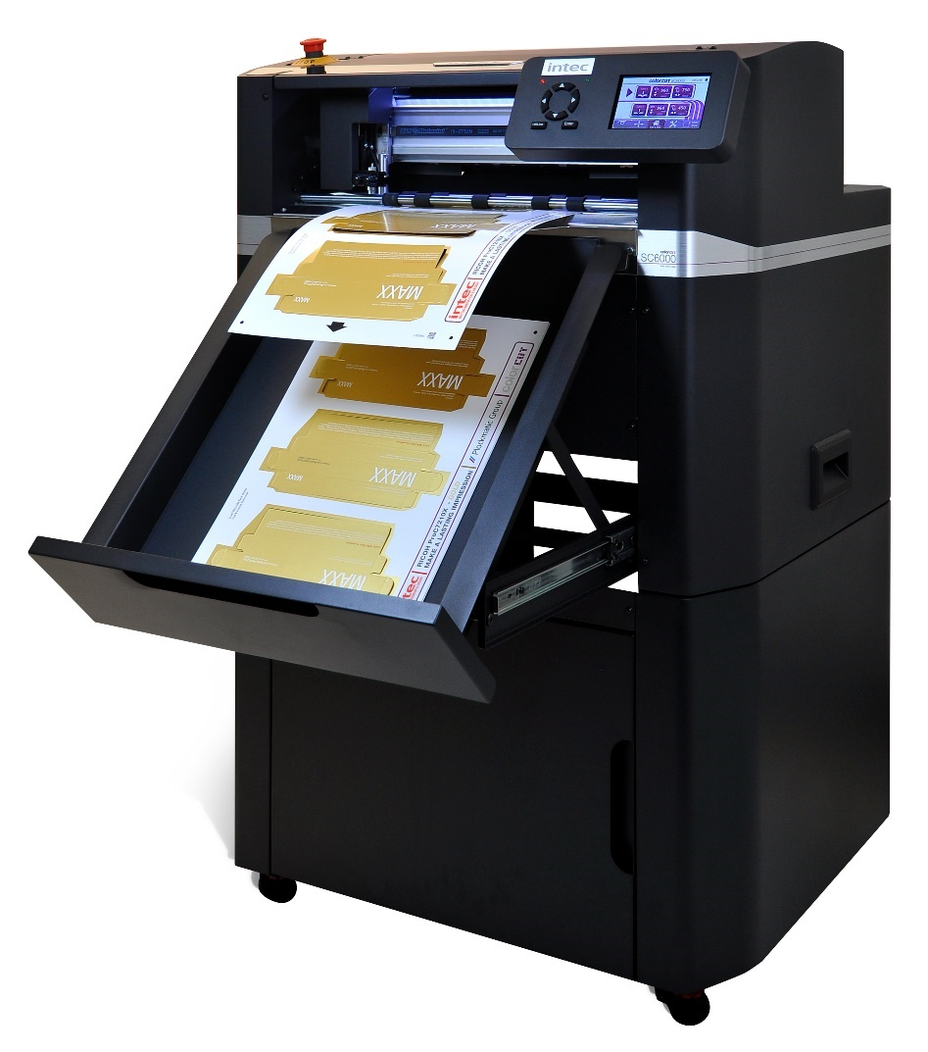
ColorCut SC6000. Automated sheet cutting & creasing, for lightweight card, packaging, P.O.S and kiss-cut sheet labels.

The NEW SC6000 is a larger format version of our exceptionally successful digital die-cutting system, the SC5000 and packed with new features!

It’s expanded size capability of 340 x 710mm allows it to handle significantly longer sheets and combines both 100% reliable high-volume auto feeding, along with a dual tool head for both cutting and creasing in a single pass.

This cost-effective unit provides rapid processing of card projects up to 350micron, packaging and kiss-cut labels with the system boasting a 900 sheet auto feeder/stacker, vacuum suction pick up belt and media collection tray offering true, unattended capability.

Mark Baker-Homes, Intec general manager states, “Intec is really excited to launch the SC6000 auto-feed digital die cutter. As a result of the Plockmatic acquisition and increased level of R&D, this new premium, compact digital die cutter, brings affordable kiss-cutting and die-cutting for card-based applications and packaging to every printer. It’s packed with advancements to enable high productivity and larger format sizes. This combined with Plockmatics exceptional build quality and reliability means businesses are able to purchase the cutter at Intec’s very affordable price points”.

The SC6000
The SC6000 is a blend of flatbed and sheet fed technologies, perfect for the fast, automated production of both die-cut and creased light-weight card for packaging and P.O.S, paper and polyester projects – as well as kiss-cut sheet label production.

High speed sheet feeding
The auto sheet feeder provides exceptional material sheet handling to deliver a faultless feed solution of sheets up to 710mm long, offering a great solution when paired with the new high volume digital printers with longer sheet capability.

Rapid cutting and creasing all in one pass
The digital cutting head can apply a force of up to 750g of pressure and cut and crease simultaneously at speeds of up to 960mm per second, enabling users to produce either one or indeed hundreds of sheets and thousands of items, unattended with its unique QR code-based system.
Grip and drive
The unique ColorCut ‘Grip and Drive’ dual roller system, holds the sheet media during cutting on BOTH sides of the cutting head, enables the SC6000 to cut closer to the media edges than other types of sheet cutter in its class.
Loves mixed jobs in the stack
Offering an unparalleled production capability to cut a mixed batch of jobs, from one load, the SC6000 seamlessly retrieves the associated cut files for an unlimited number of different jobs in the stack. This is totally instant and with zero delay, enabling a seamless and uninterrupted workflow and reduces the need for highly trained operators.

Using QR codes for cut file recognition, with the cutters CCD camera quickly reading a printed code to retrieve the sheets associated cut file, and four corner marks to ensure accuracy of cut and crease with the printed artwork. Whilst feeding the software compensates for any sheet feeding skew or print stretch. This function also enables the operator to instantly view the job on screen and set the desired cutting features from the systems material database, built to enable processing pre-sets for regularly used materials. This means that different aspects of the file can have different treatments applied to them and also predetermine the order they are processed in the cutter.

The cutter is driven using Intec’s Production Studio package (included with the system), which is part of Intec’s acclaimed ColorCut Pro software suite. This can be used as a stand-alone application, with the cutter or as part of a networked solution, when used in conjunction with Intec’s ColorCut Pro Server Station. The ColorCut Pro software suite offers sophisticated features with Job Library Manager workflow application and Template Maker for producing vector box templates, to load into Adobe Illustrator or CorelDRAW, for use with the cutter.

Compact and fully-mobile
Free-standing and fully-mobile, the SC600 has been designed with space saving in mind. It features a retractable media catch tray that slides away when not in use, ensuring that its sub-1sq metre footprint can easily be accommodated in any print shop.

Further information

Product video:
https://youtu.be/hTU76VTYKww

Link to brochure:https://intecprinters.com/wp-content/uploads/2023/02/SC6000-EN-web.pdf

Website page:
https://intecprinters.com/products/digital-cutting-devices-for-print-work/automated-cutters/sc6000-auto-sheet-cutter

Image requests:
marketing@intecprinters.com

About Intec
Intec Printing Solutions Limited, is the manufacturer and distributor of the global finishing solutions brand, Intec with its head office based in Poole, Dorset UK. The company is a wholly owned subsidiary of Plockmatic International AB and part of the Plockmatic Group: www.plockmaticgroup.com

Follow Intec Online

Website: www.intecprinters.com Follow us on Twitter: @IntecPrinters Find us on Facebook: Intec Printing Solutions
View us on YouTube: www.youtube.com/intecprinter Join us on LinkedIn: Intec Online
NOTE TO EDITORS: The Intec brand names and products are the intellectual property and copyright of Intec Printing Solutions Limited. All other terms and product names may be trademarks or registered trademarks of their respective owners and are hereby acknowledged.
Contact Information
Terri Winstanley, Intec Printing Solutions Ltd. Phone: +44 (0)1202 845 960 Email: marketing@intecprinters.com

ENDS
………………………………………………………………………………………………………………………

