I Press Release
Immediate release

New Intec SC6500 auto-feeding digital die-cutter for lightweight packaging and label production.
United Kingdom, 1st September 2023 – Known for its innovative auto-feed cutting solutions, Intec Printing Solutions Limited, releases the ColorCut SC6500 Sheet Cutter.
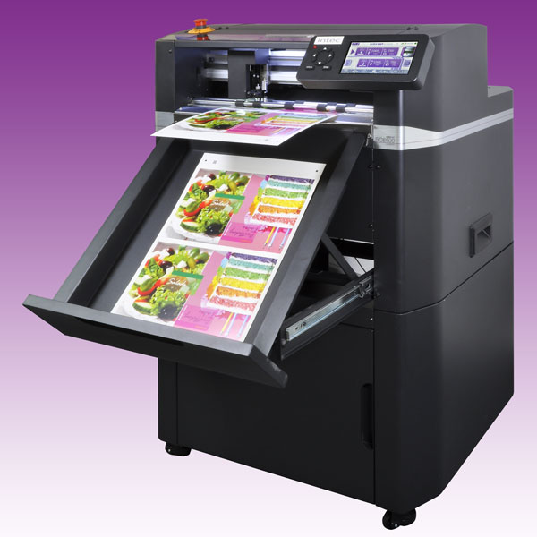
ColorCut SC6500. Automated sheet cutting & creasing, for lightweight card, packaging, P.O.S and kiss-cut sheet labels.

The NEW SC6500 follows on from the successful launch of the SC6000 earlier this year, adding to Intec’s compact cutter range and is packed with new features! The SC6500 is simple to use, more productive and extremely energy efficient, helping to cut operation costs – possibly one of the most energy efficient, production cutters, in the market today!
The SC6500 enables digital, on demand cutting and creasing, at a truly affordable price point for a range of applications. This allows printers and manufacturing operations to quickly and easily adapt any artwork, to cut shapes without a physical die and can be placed at the end of a production line. Its aims to provide a sensible and cost-effective solution for the manufacturing and production sector of the market, with its new ‘no wires’ working approach.

Providing rapid processing of card projects up to 350micron, packaging and kiss-cut labels, the system boasts a 1,000 sheet auto-feed stacker, vacuum suction pick-up belt and media collection tray to offer true, unattended production. Coupled with this, the new SC6500 provides excellent media feeding with a range of new features included in the new Media Control Centre to ensure faultless feeding. Features include; gravity restack timing and stack height adjustment, sheet separation with air-blade power adjustment, vacuum belt pickup control and sheet transport speed settings.

Mark Baker-Homes, Intec general manager states, “The SC6500 is a very exciting new addition to our compact digital cutter range. This model is the first release that hosts a new high-powered controller and expanded graphics interface. The SC6500 is packed with a host of new features and its energy efficiency is second to none! Because of this it can be used as a standalone device, placed anywhere there is a power source, in any production or manufacturing environment!

The SC6500 now offers 2 working modes; DIRECT – using Intec’s industry acclaimed ColorCut Pro software direct from a PC or HELD mode (standalone operation) where jobs can be stored internally or on a USB stick, so anyone can process a stack of printed sheets! Simply wheel the cutter to any point of your production environment, or remote location, plug in to a mains outlet or run using a standalone power/solar pack, load with media, click SCAN on the 7" touch screen and run!

Further information

Product video: https://youtu.be/jVvSpCAvJJs

Link to brochure: https://intecprinters.com/wp-content/uploads/2023/09/SC6500-EN-web.pdf

Website page: https://intecprinters.com/products/digital-cutting-devices-for-print-work/automated-cutters/sc6500-auto-sheet-cutter/

Image requests:
marketing@intecprinters.com or download the image pack or scan the QR code to download: https://intecprinters.iweb-storage.com/s/IjY0ZjcxNzAwZmZhOWQ5NTliZmY2ZDQyOCI.FAS1Hdf3o_njage7l6cd3B3N5Bw

About Intec
Intec Printing Solutions Limited, is the manufacturer and distributor of the global finishing solutions brand, Intec with its head office based in Poole, Dorset UK. The company is a wholly owned subsidiary of Plockmatic International AB and part of the Plockmatic Group: www.plockmaticgroup.com

Follow Intec Online

Website: www.intecprinters.com Follow us on Twitter: @IntecPrinters Find us on Facebook: Intec Printing Solutions
View us on YouTube: www.youtube.com/intecprinter Join us on LinkedIn: Intec Online
NOTE TO EDITORS: The Intec brand names and products are the intellectual property and copyright of Intec Printing Solutions Limited. All other terms and product names may be trademarks or registered trademarks of their respective owners and are hereby acknowledged.
Contact Information
Terri Winstanley, Intec Printing Solutions Ltd. Phone: +44 (0)1202 845 960 Email: marketing@intecprinters.com

ENDS
………………………………………………………………………………………………………………………

